Chapter 2, Problem 18.

Find I and V_{ab} in the circuit of Fig. 2.82.

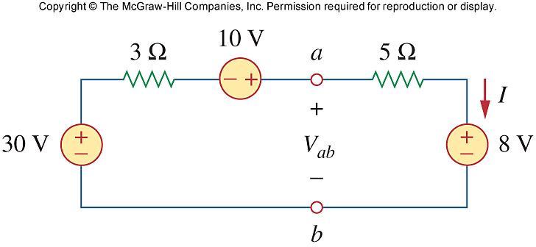

Figure 2.82
For Prob. 2.18.

